**Otterbox Defender Series for iPad**

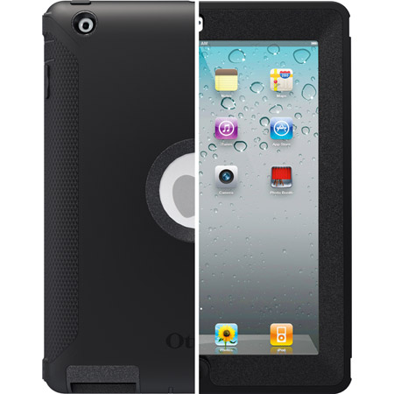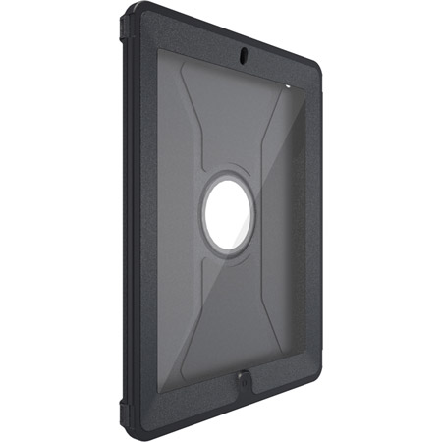

**Features:**

The Defender Series iPad 2 case employs multi-layer technology built with   
high-quality materials to create a rock-solid protective solution. The inner shell of the iPad case is composed of high-impact polycarbonate and includes a foam interior that delivers added shock absorption and protects the back of your iPad from scratches. The rugged silicone outer-layer absorbs impact from bumps and shocks while the textured exterior provides enhanced grip. The built-in screen protector prevents scratches, smudges and fingerprints from getting on your screen. The integrated shield stand acts as a protective cover on the front or the back and doubles as a kickstand for typing or viewing. Get protection that inspires confidence with the Defender Series.